**Abstract**

**Multi User Massive MIMO (MU-MIMO) is a form of multi-user MIMO technology in which hundreds numbers of antennas serve a significantly smaller number of users. We focus to analyze the downlink system of MU-Massive MIMO which works on Rayleigh and Uniformly Random Line of Sight (UR-LOS) channel. This system is assumed operates over a frequency-selective and uses Orthogonal Frequency Division Multiplexing (OFDM). The system performance is observed in perfect CSI and imprefect CSI condition. ZF and MMSE linier precoding are used to overcome MUI at receiver. From the simulation results, it can be seen that the use of a large number of antenna arrays can significantly increase the spectral efficiency without bound. In addition, the spectral efficiency of the downlink scheme really depends on the use of precoding techniques. ZF and MMSE work equally well in suppressing the MUI at large number of antenna elements.**

***Index Terms –* Massive MIMO, Rayleigh, UR-LOS, Perfect CSI, Imperfect CSI, Least-Square Estimation, Spectral Efficiency, ZF, MMSE.**

1. **INTRODUCTION**

In recent years, Multiple Input Multiple Output (MIMO) technology has been developed to support the development of high-speed wireless communication systems. This technology has better performance than Single Input Single Output (SISO). This concept becomes the background for the development of the Massive MIMO system. Massive MIMO system is a system that uses a very large number of antennas on the BS side, the antennas used can be hundreds or even more [4]. The use of massive antenna elements can increase spectral efficiency and energy efficiency significantly, compared to the small-scale MIMO system.

In order to serve multiple users simultaneously, the Multi User Massive MIMO (MU-Massive MIMO) system is used. Hundreds of antennas on one BS can serve tens of users simultaneously, where each user uses a single antenna. The advantages of single antenna users are that it is inexpensive, simple and uses more efficient power, but each user can still get a high throughput [12].

The design and analysis of the Massive MIMO system is an interesting subject to study [a] - [d]. Some advantages of the Massive MIMO system compared to conventional MIMO are, only the BS needs to estimate the channel, the number of BS antennas is much greater than the number of users, and simple linear precoding techniques can be applied both on the uplink and downlink side [5].

In order to implement the MU-Massive MIMO system which represents the real conditions, channel estimation on the BS or user side is required. However, channel estimation will be very complex because it is proportional to the very large number of BS antennas, hence some previous research on Massive MIMO systems assumed perfect CSI conditions on both the BS and the user side [6] [7]. Even though in actual conditions the channel can change at any time according to the propagation environment conditions, so estimation channel is required. This is because CSI is not only useful for obtaining high SNR on the user's side, but also in reducing interference generated by other users in a cell. The existence of a channel estimate on the BS side is known as Imperfect CSI condition, because the BS only know the noisy version of the channel.

We assume that the system works on TDD operation, so that he uplink and downlink channels be reciprocal. BS can obtain CSI from the uplink training. The number of transmitted pilots is proportional to the number of users which is much smaller than the number of BS antennas. Then BS use the CSI to precode the transmitted signal in order to reducing MUI.

This paper analyses a single cell MU-Massive MIMO communication system with a downlink scheme on the Rayleigh channel and the Uniformly Random Line of Sight (UR-LOS) channel.This system is assumed operates over a frequency-selective and uses Orthogonal Frequency Division Multiplexing (OFDM). The system performance is observed in spesific conditions. First, we assume that the BS knows channel information (Perfect CSI). And the second condition, BS estimates the channel at a certain coherence interval (Imperfect CSI). We use Least-Square Estimation method to estimate the channel respons which is obtained from the pilot sent by users. The observed parameters are Bit Error Rate (BER) and Spectral Efficiency using Zero Frocing (ZF) and Minimum Mean Square Error (MMSE) linear precoding technique .

It is shown that the use of large-scale antennas on the BS, the spectral efficiency will increase without bound. So that the use of the massive number of antenna elements with a constant number of users will significantly increase the spectral efficiency. In addition, the downlink SE for the k-th user in a cell really depends on the precoding. By using precoding, each signal is sent from all antennas but with a difference in amplitude and phase, so that the signal will sent directly to users[11]

**System Model**

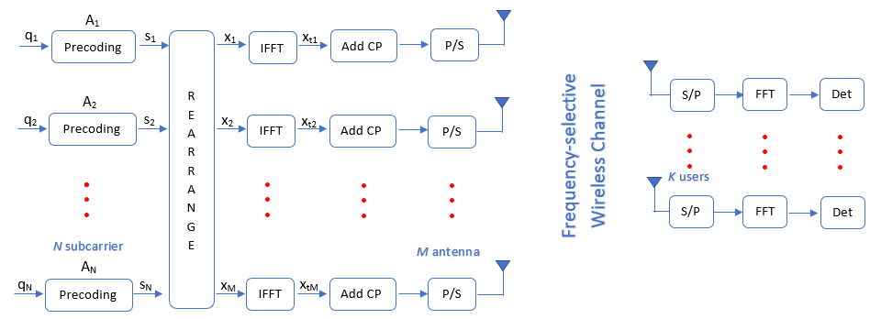

The downlink system of Multi User Massive MIMO (MU-Massive MIMO) is shown in Figure 1. BS is equipped *M* number of antenna and simultaneously serves a number of *K* users, each user uses a single antenna, where M is much larger than *K (M≫K).* This system is assumed to work on a frequency-selective channel, so the OFDM technique is used to overcome Intersymbol Interference (ISI). Vector signal $q_{n}∈C^{M×1}$ contains QAM modulated symbols at *n-*thsubcarrier, n = 1,2,3,…*N* are total OFDM subcarriers. In fact, OFDM has subcarriers designed for data transmission ${(N}_{d})$ and unused subcarriers for guard band ${(N}_{g})$. So that there are no signal transmitted on the guard band $q_{n}∈ 0^{M×1}$.

In perfect CSI condition, it is assumed that BS already knows channel information (CSI) and use it to precode the transmitted signal. We focus on analyzing the system performance on Rayleigh and UR-LOS channel. The matrix $H_{l}∈C^{K×M}$ is time domain channel response in Rayleigh condition associated with L number of channel taps, where $l=1,2,..L$. The content of this matrix is ${\left[H_{l}\right]}_{k,m}\sim CN\left(0,1/L\right).$

The second channel condition is Uniformly Random Line of Sight (UR-LOS) where there is no local scattering between BS and user. And all user has line of sight to the BS antennas. The time domain channel response is described as follows:

$$h_{k}= \sqrt{β}{\left[1 e^{2πjdHsinθ_{k}}. . .e^{2πjdH(M-1)sinθ_{k}}\right]}^{T}$$

Where $h_{k}$ is channel responses associated with *k-*th user, $β$ is large-scale fading coefficient, $dH$ is array spacing and $θ_{k}$ is angular position of each user which is measured relative to array boresight. User position is random and $sin{(θ}_{k})$ is uniformly distributed at interval $\left[{-π}/2 π/2\right].$ BS uses Uniform Linear Array (ULA) antennas. Where ULA can only detect the user's position uniquely at intervals $\left[{-π}/2 π/2\right]$.

Channel matrix $\left\{H_{l}\right\}$ is assumed to be constant at certain coherence intervals. In the imperfect CSI condition, BS needs to estimate the channel response. The channel estimation is obtained from the pilot which is transmitted by all users. At each coherence interval, each user transmits $τ_{p}$ orthogonal pilot, which are known both end ef the links. The number of transmitted pilots must be greater than the number of users $(τ_{p}≥K$). Collectively, all users transmit $K×τ_{p}$ pilots. We limit the uplink transmitted signal only contains pilot signals only. This pilot signal is transmitted using *N­* numbers of subcarriers. So that the received pilot signal at ­*n­-*th subcariier is:

$$y_{pn}=H_{n}x_{pn}+w_{n}$$

Where $x_{pn}$ is pilot signal, $H_{n}$ is channel response to be estimated and $w_{n}$ is AWGN noise. Then BS will estimate the channel from the received pilot signal using Least Square Estimation method. The estimated channel matrix for all subcarriers is:

$$\hat{H}= {({X_{p}}^{H}X_{p})}^{-1}{X_{p}}^{H}Y_{p}={X_{p}}^{-1}Y_{p}$$

The channel estimation error is ${\tilde{H}}_{n}={\hat{H}}_{n}-H_{n}$. So the Mean Square Error (MSE) of the channel estimation results is $E\left\{{\left|{\tilde{H}}_{n}\right|}^{2}\right\}$. After BS knows channel information, then BS uses this channel matrix to precode the transmited signals. There are several simple linear precoding techniques that can be applied to massive MIMO systems. In this paper we use Zero Forcing (ZF) and Minimum Mean-Square Error (MMSE) and described as follows

$${A_{ZF}= H}_{n}^{H}{\left(H_{n}H_{n}^{H}\right)}^{-1}$$

$${A_{MMSE}= H}_{n}^{H}{\left(H_{n}H_{n}^{H}+\frac{K}{p_{d}}I_{K}\right)}^{-1}$$

Where $A$ is precoding matiks, $p_{d}$ is downlink SNR and $I_{K}$ is $\left(K×K\right)$ identity matrix. To satisfied the total power constraint on the BS, the precoding matrix should be multiplied by a scale factor

$$α= \frac{1}{\sqrt{\sum_{n=0}^{N-1}{(tr{A_{n}A_{n}^{H})}/N}}}$$

Next, the symbols in each subcarrier are multiplied by precoding matrix. As a result is precoded vector $c_{n}{∈C}^{M×1}$ which contains the symbol that will be transmitted to *n*-th subcarrier via *M* antenna BS. In order to transmit *N* precoded vector to *M* BS antenna, rearrange process is needed and yield reodered vector $x_{m}$. This means that each antenna transmits the signal from all subcarriers.

$$\left[x_{1 . . . } x_{M}\right]= {\left[s_{1 . . . } s_{N}\right]}^{T}$$

A number of *M* vector $x_{m}$ are frequency-domain signals that will be transmitted over M antennas. Time-domain signal ${xt}_{m}$ obtained by aplying an Inverse Fast Fourier transform (IFFT) of $x_{m}$. Cyclic prefix is added to time-domain signal to overcome Intersymbol Interference (ISI).